Tracking Change: The Run Chart

- Measurement is central to quality improvement, providing evidence of change and thus guiding widespread implementation
- Measures can include outcomes such as COVID-19 testing rates, incidence rates, hospitalization rates, or vaccination rates to smaller process change indicators such as tracking documentation of patient education dissemination and vaccine denials
- Measures can be generated by the IT department (weekly reports), manual chart sampling, or contemporaneous tracking (MA or nurse marks a form for each documentation they provide)
- Integral to the PDSA process, early evidence of success as shown in a run chart recommends expansion of the process to a bigger part of the practice and health care system.
One can take advantage of a programmed Excel spreadsheet to enter performance data and generate a run chart – see attached.
Below is an example of a run chart from based on example 1 in the DRIVE online toolkit. In the toolkit example, a practice hopes to increase COVID-19 vaccinations in Black patients 65 or older with diabetes by 20% for the last 3 months. Due to the nature of the COVID-19 vaccine rollout, the clinic was only able to vaccinate on certain dates due to short supply.
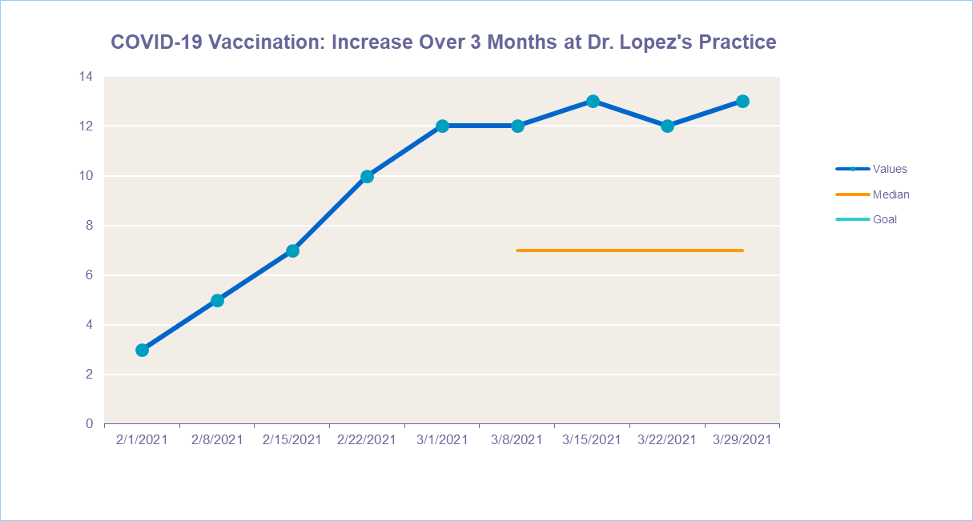

Select References: AMA STEPSforward, Plan-Do-Study-Act (PDSA) Accelerate Quality Improvement in Your Practice. https://edhub.ama-assn.org/steps-forward/module/2702507

